The following explains in detail our method of generating training sets.

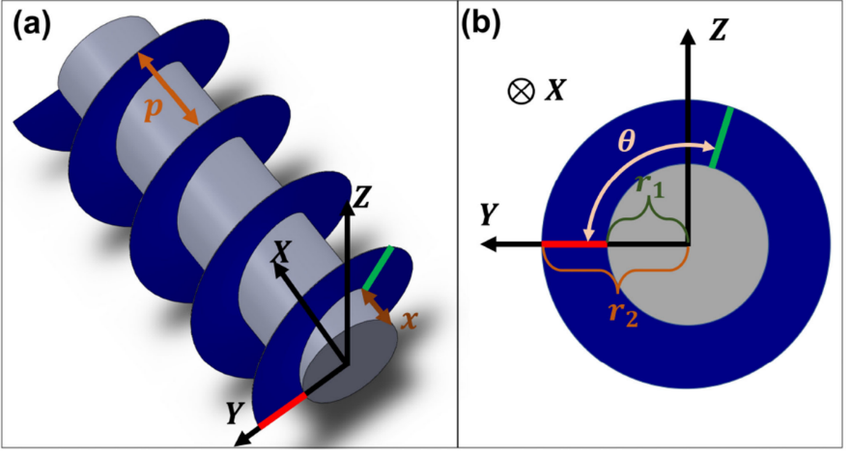

Fig. 1. The geometric definition of a screw-propelled wheel. (A) An overview of a screw-propelled wheel. A screw-propelled wheel comprises a screw cylinder (gray part) and a screw blade (blue part). p is the pitch of the screw blade. The world frame is shown. (B) In the view of X axis, θ is defined as the slope angle between the current and the initial generatrix. r1 indicates the screw cylinder’s radius, and r2 indicates the screw blade’s radius.

First of all, it should be clear that the screw-propelled wheel can be expressed by the following equation:

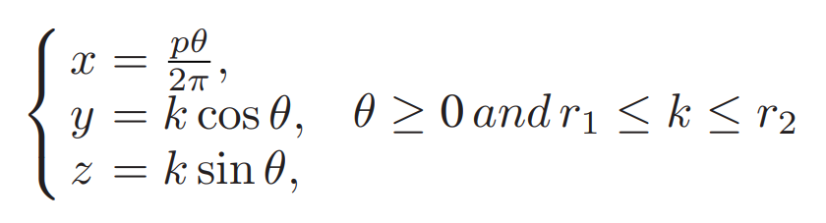

where p is the screw pitch, θ is the slope angle. r1 is the screw cylinder’s radius, r2 is the screw blade’s radius. The initial generatrix (θ = 0) lies in the Y -Z plane of the global frame. For the initial generatrix, k indicates the value of coordinate y and is controlled by the screw cylinder’s radius r1 and the screw blade’s radius r2.

To make a screw-propelled wheel have better mechanical characteristics, our method is to optimize the generatrix of helicoid while keeping r1 and r2 unchanged. The advantage of this method is that it can improve the robot’s mobility without increasing the size. Due to the approximation ability of high-order polynomials to the curve, we replace the generatrix of the normal screw-propelled wheel with quartic polynomials. We set the initial generatrix as: $z=α_{4}k^{4}+α_{3}k^{3}+α_{3}k^{3}+α_{4}k$. $α=[α_{4}, α_{3}, α_{2}, α_{1}]$ is the polynomial coefficient. When $α$ = 0, it changes to a normal screw-propelled wheel. Thus, the coordinates of any point on the helicoid S can be obtained:

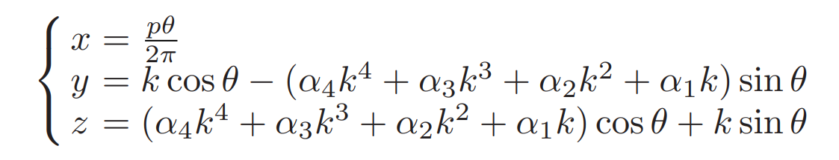

We generate samples with different shapes by randomizing the vector $α$. At the same time, we limit the generated samples in the yellow area and set the generatrix to start and end at the endpoints in Fig. 2 to avoid excessive differences.

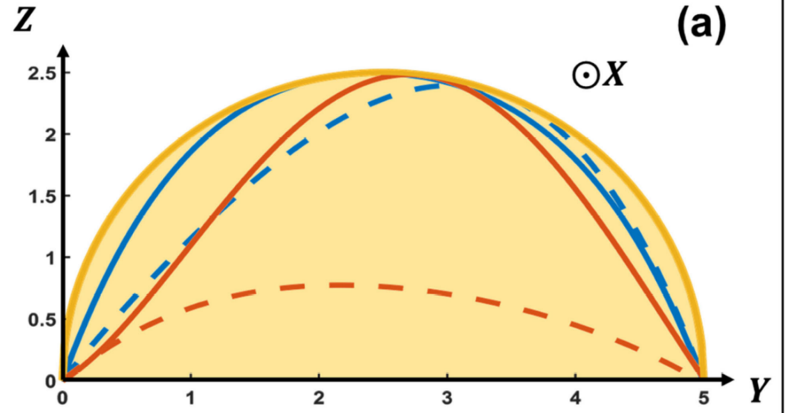

Fig. 2. The optimization results of screw-propelled wheel. The optimization results of the generatrix. The feasible solution of the generatrix is limited to the yellow area and to start from point (0,0) to point (5,0).

Through the above method, we generated about 9000 point cloud samples for training sets.